ANED 2014 Task 5 – European semester country fiche on disability

Country: Lithuania

Author(s): Jonas Ruskus, Egidijus Elijosius, Roberta Motieciene
With comparative data provided by the ANED core team

The Academic Network of European Disability experts (ANED) was established by the European Commission in 2008 to provide scientific support and advice for its disability policy Unit. In particular, the activities of the Network will support the future development of the EU Disability Action Plan and practical implementation of the United Nations Convention on the Rights of Disabled People.

This country report has been prepared as input for the Flash synthesis report on the European Semester.

Summary of the overall situation and challenges

Regarding the United Nations Convention on the Rights of Persons with Disabilities implementation challenges in Lithuania: there have been 4 years of experience (LT signed the Convention in 2007, and The Parliament adopted this law in May of 2010). The Office of the Equal Opportunities Ombudsman of Lithuania performed research on possible discrimination. It must be emphasised that the provisions of the Convention countries (States Parties) require not only the prohibition of discrimination based on disability and measures to deal with it, but Article 5 of the Convention also requires the taking of active steps for the removal of inequality, in areas where people have a disability disadvantage compared with other persons. Special temporary measures (Positive action measures) to ensure equality are implemented by the Republic of Lithuania through the Law on Equal Opportunities (Law on Equal Treatment). However, the law states that such measures may be determined exclusively by the law. Thus, the legislator is directly responsible for a very important feature - active actions to remove the entrenched inequality of persons with disabilities in society. With the Law and National Reform Programme (NRP-2014), Specific Plans and Documents in Lithuania – conform to requirements but in reality the life quality of people from socially disadvantaged groups (and persons with disabilities) is poor due to income below the average cost of living.

Service providers for people with disabilities and non-governmental organizations, and they are increasingly active.

Reviewing the implementation of the Convention with 4 years of experience in office draws attention to a few problem areas, which need to be urgently addressed (OEOO adviser Muliuolis V.):

- There is a need to promote special temporary measures (Positive action measures) with the aim of actual equality of persons with disabilities in many areas of public life (participation in the labor market, environment improvement, provision of social housing (Housing), etc.).
- Information dissemination and promotion of cooperation with state and municipal institutions in particular. In practice, there are problems with knowledge of the principles of the Convention and the lack of obligations.
- To promote social dialogue and cooperation with organizations which represent the interests of disabled people. Disability is a very diverse concept that connects people with different specific needs. For this reason, it is necessary to maximize the representation and participation of disabled people in all stages of the implementation of the Convention.
- The need for an independent Office with real political powers, for the surveillance (monitoring) of the Convention, established with authority (under the Convention, Art. 33).

Assessment of the situation of disabled people with respect to the Europe 2020 headline targets

Strategic targets

Table 1: Europe 2020 and agreed national targets for the general population
 | Europe 2020 targets | National targets
Employment | 75% of 20-64 year-olds to be employed | 72.8%
Education | Reducing the rates of early school leaving below 10% | <9%
Education | At least 40% of 30-34–year-olds completing third level education | 48.7%
Fighting poverty and social exclusion | At least 20 million fewer people in or at risk of poverty and social exclusion | Reducing the number of persons at risk of poverty or social exclusion to 814,000

Any relevant disability targets from national strategies or sources:
At the beginning of 2014, work incapacity pensions were paid to 253 700 residents of Lithuania, i.e. 1.8 per cent less than in 2013. The numbers of men and women receiving disability pensions differ to a slight extent: 48 per cent of men and 52 per cent of women. The number of disabled children was 15 000.

Most often persons of working age are recognised as disabled due to malignant tumours, diseases of the blood circulation system, connective tissue and skeletomuscular system diseases. The most severe disability is most frequently caused by tumours, diseases of the blood circulation system and mental and behavioural disorders.

Mental and behavioural disorders, congenital developmental diseases, deformations, anomalies in chromosomes and diseases of the nervous system are the main causes of disability of children.

Equal opportunities are one of the most important values and principles of modern society. The Constitution and many laws of the Republic of Lithuania governing various social relations stipulate the constitutional principle of equality before the law. Every member of society must have equal opportunities to seek education, career, personal development, act in all areas of political and social activities, as well as freely move in the EU.

Lithuanian residents have been actively enjoying the rights of movement of persons and free movement of workers in the EU and using the opportunity almost without constraints to become employed in any European Union Member State.

Although the number of persons who have been recognised as disabled for the first time has been decreasing, it is important to further create opportunities for just and efficient provision of social security measures to the disabled, seek their capacity for work, restore self-sufficiency and seek integration in society.

ALL information is from the RESOLUTION on CONVERGENCE PROGRAMME in LITHUANIA 2014 – 2014-04-16, No.346; Office of the Government of the Republic of Lithuania (NRP) (in Lithuanian):
2.1. implementation of budgetary policy to ensure economic growth, employment, unemployment, poverty and social exclusion;
2.4. reduce the State Social Insurance Fund debt, and the recovery of the economy - a consistent increase of pensions (and for disabled) and other social benefits;
2.6. to improve the education and science policy (including and inclusion education);

Some Indicators |  | Indicator  Value on 2013 | Percentage changes
 |  | Indicator  Value on 2013 | 2013 | 2014 | 2015 | 2016 | 2017
1. | Employment, the number of people in thousands | 1 292.8 | 1.3 | 1.5 | 1.3 | 0.8 | 0.6
3. | The unemployment rate, as a percentage | 11.8 | – | 10.5 | 9.0 | 7.8 | 6.5

New in Lithuania - „Increasing Employment for the 2014-2020 program approval“ and a separate document „Increasing Employment for 2014-2020 in the program inter-institutional action plan approval“ - the measures refer to in the medium term working employed population and the number of contingent workers per year on average to grow 2.1 to 2.4 percentage points faster, including people with disabilities.

RESOLUTION on CONVERGENCE PROGRAMME in LITHUANIA 2014 – 2014-04-16, No.346; Office of the Government of the Republic of Lithuania (NRP) (in Lithuanian). SOCIAL SECURITY SYSTEM REFORM (chapter 43-45):
44.1. since 2012, to begin to raise the retirement age - added annually after 4 months to 2 months and women - to men's retirement age, until in 2026 the retirement age for both sexes to 65 years (for all population in LT)
44.2. replace social security procedure for the calculation of pensions - a gradual transition to the new basic pension or national pension financed out of general taxation
44.4. calculating pension insurance contributions and earnings from income-changing

RESOLUTION on CONVERGENCE PROGRAMME in LITHUANIA 2014 – 2014-04-16, No.346; Office of the Government of the Republic of Lithuania (NRP) (in Lithuanian) HEALTH CARE SYSTEM REFORM (chapter 46-51):
46. (…) Lithuania's population is shrinking and aging. Aging of the population means a decline of working people, more and more need for health and social care services, thus increasing costs and health care.
When a country's population is healthy and active for a long time, this is a positive effect on labour productivity, reduced social exclusion and poverty risk.
47. (…) In order to reduce the negative impact on the health problems in society's capacity to work until the end of 2015 the implementation of morbidity and mortality from the main non-infectious diseases Reduction Programme for 2007-2013.

RESOLUTION on CONVERGENCE PROGRAMME in LITHUANIA 2014 – 2014-04-16, No.346; Office of the Government of the Republic of Lithuania (NRP) (in Lithuanian) SCIENCE AND EDUCATION SYSTEM REFORM (chapter 52-58):
52. Lithuania approved two key strategic documents covered will be used to implement the basic state appropriations in this field, including the EU structural support: “The National Education Strategy for 2013-2022” and “State Programme of study, research and experimental (social, cultural) development 2013-2020”.
56. (…) Improving access to studies, in 2013, 15.064 students granted scholarships social semester (planned 13.000), offset 100 percent of the price paid for studies not financed by the state for students from socially disadvantaged groups (including persons with disabilities). 25-34 per thousand population were 3.03 doctoral graduate students (expected 1.05) - the scientific potential is also strengthened.

More in details in quantitative expression: Lithuania: National Reform Programme 2014 (in English, p. 35)

4.8. Reducing Poverty and Social Exclusion
According to data of the survey on Income and Living Conditions conducted in 2012, 975 thousand residents, or 32.6 percent of Lithuania’s population, were at risk of poverty or social exclusion. The number of residents at risk of poverty or social exclusion decreased by 3.6 percent, compared to the previous year. The number of persons whose income was lower than the at risk of poverty threshold declined by 4.6 percent, from 586 thousand to 559 thousand. In the view of the reduction of the risk of poverty level and increase of the at-risk of poverty threshold by 12.5 percent from LTL 666 to LTL 749, growth rate of low income can be stated to have been more rapid than that of residents receiving greater income. Increasing employment decreased the number of individuals living in households with very low work intensity levels, i.e. their number dropped by 12.5 percent during the year, from 296 thousand to 259 thousand persons. However, the number of persons suffering severe material deprivation grew by 2.8 percent. Severe material deprivation was mostly suffered by single person households or households consisting of three adults with children.

In order to implement the commitment assumed by Lithuania to reduce the number of individuals living at risk of poverty or social exclusion to 814.000 by 2020, it is necessary to increase the possibilities of residents to actively participate in the labour market and public life, promote social innovation and the development thereof and to seek for a more efficient use of funds allocated for the implementation of social policy. (Lithuania: National Reform Programme 2014)

A note on the use of EU data
Unless specified, the summary statistics presented in this report are drawn from 2012 EU-SILC micro data. The EU-SILC sample includes people living in private households and does not include people living in institutions. The proxy used to identify people with disabilities (impairments) is whether ‘for at least the past 6 months’ the respondent reports that they have been ‘limited because of a health problem in activities people usually do’. Responses to this question vary between countries and national data sources are added for comparison, where available.

Table 2: Self-reported ‘activity limitations’ as a proxy for impairment/disability (EU-SILC 2012)
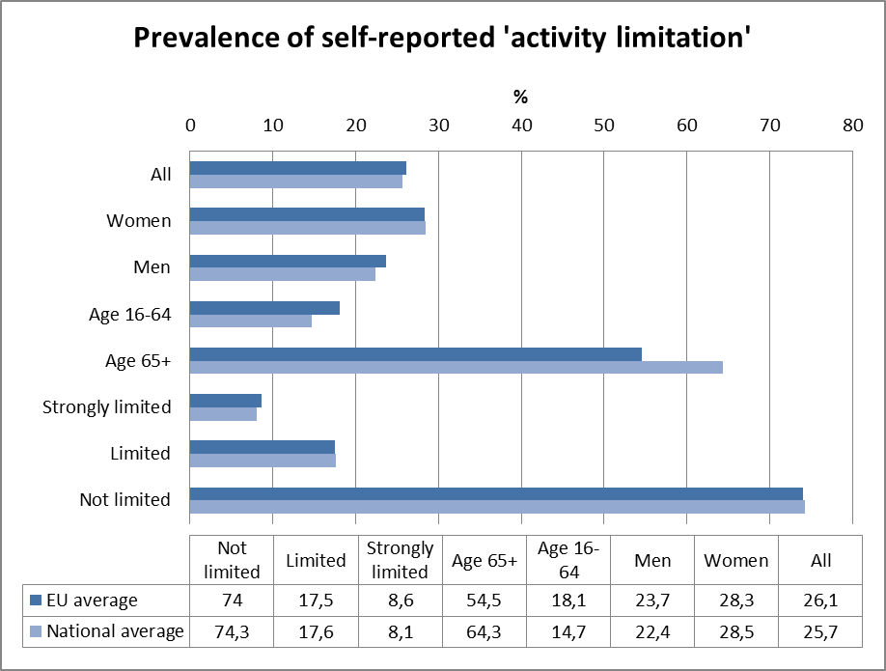
Source: EUSILC UDB 2012 – version 2 of August 2014

In subsequent tables, these data are used to estimate outcomes for ‘disabled’ people in the main target areas for EU2020 – employment, education and poverty risk. Due to the very small number of observations for young people in Lithuania (aged 16-24) no clear indication can be interpreted from the results for this age group.

Employment data

Table 3: Most recent employment data, aged 20-64
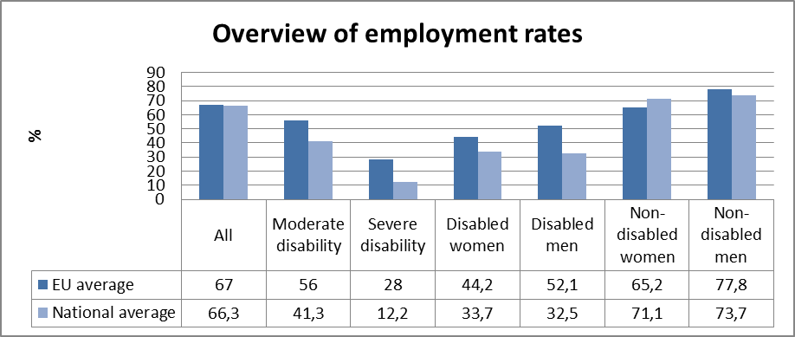

Table 4: Employment rate data, by age group
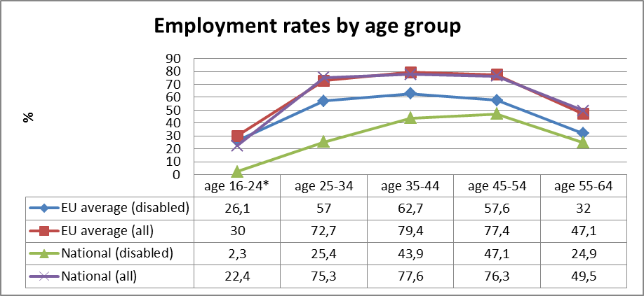
Table 5: comparison of data from EU-SILC (2012) and the LFS ad hoc disability module (2011)
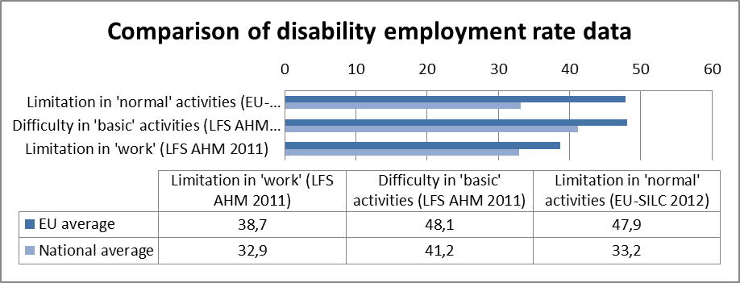
Source: EUSILC UDB 2012 – version 2 of August 2014, and Eurostat LFS AHM 2011

Table 6: Five-year trends in employment by gender and disability (aged 20-64)
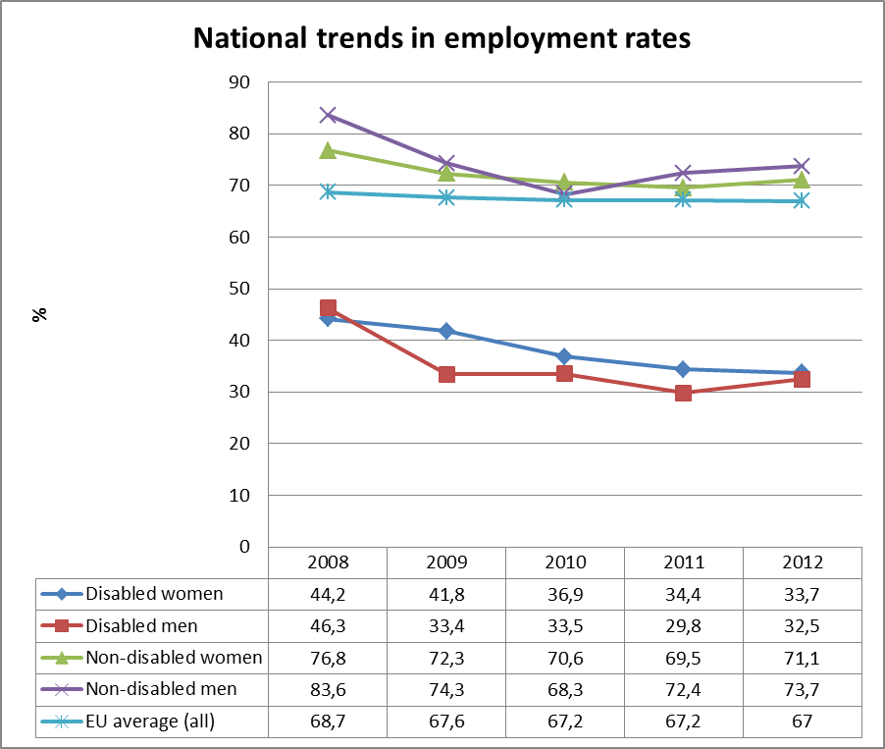
Source: EUSILC UDB 2012 – version 2 of August 2014 (and preceding UDBs)

Alternative data on disability and employment from national sources:
Lithuania does not have a concrete national law, which would be oriented to non-discrimination in employment only, though general indications are provided in the Law on Support for Employment (No X-694 - actual editing 10 July 2014, in Lithuanian only); Law on Equal Treatment (IX-1826, 2003), Law on Social Integration of Disabled People (IX-2228, 2004) provides that employers have to 'take appropriate measures to provide conditions for the disabled to obtain work, to work, to a career or to study, provided that the duties of the employer would not be disproportionately burdened as a result'. The main objective of the Law on Social Integration of Disabled People (IX-2228, 2004) is to ensure disabled people’s equal rights and opportunities in society, to determine preconditions and conditions of the social integration system, responsible institutions, incapacity to work levels, professional rehabilitation services, and special needs. This law pays particular attention to professional rehabilitation. Professional rehabilitation is defined as rehabilitation or improvement of an individual's capacity for work, professional competence and ability to participate in the labour market by using educational, social, psychological, rehabilitation and other measures.

The Law on Education (No XI-1281, 2011) is oriented to non-discrimination in employment: free educational assistance (vocational guidance, informational, psychological, socio-pedagogical, special pedagogical and special assistance of education, healthcare at school, consultation, in-service training of teachers and other assistance) in educational system (Chapter 2, Article 6); in separate cases, set out in the list, approved by the order of the Minister of Education and Science, of general criteria for admission to a state and a municipal general education school, vocational training school, vocational education and training may be provided to learners with special educational needs even without a required education level (Chapter 2, Article 12).

Law on Vocational Education (No VIII-450 - actual editing 20 June 2014, in Lithuanian only) is oriented to non-discrimination in vocational education system: primary vocational education is guaranteed for people who have studied according to special training programmes (Chapter 2, Article 6, no.3).

In the Law on Support for Employment (No X-694 - actual editing 10 July 2014, in Lithuanian only) at Article 4. Persons Additionally Supported in the Labour Market are included all disabled groups, but recent re-editing of the Law, has weakened provision for disabled people.

Increasing employment. (Lithuania: National Reform Programme 2014)
Improve the employability of young people, for example through a Youth Guarantee (p. 11). The implementation of the measure Support for the First Job, funded from the European social fund, was launched on 1 August 2012, and was continued in 2013, and 2014. In order to encourage employers to hire young people, a part of the salary of 16-29 year old persons, who have not yet been employed under an employment agreement, and who are employed full-time for the first time, is reimbursed. An employer is compensated 23.3 percent of the calculated salary amount for a period no longer than 12 months. By 31 December 2013, LTL 10 million was paid out to 9.062 employed young persons and 1,714 companies received support for this.

Young people (up to 29 years of age) are one of the priority groups having a opportunity to make use of the financial engineering instrument Promoting Entrepreneurship, funded from the European Social Fund.

The implementation of the National Youth Volunteering Programme was started in 2013. During the 18-month programme implementation period, 200 hiring public organisations will admit up to 6 volunteers for a period of 3-6 months. Young people participating in the volunteering project will acquire skills necessary for more conscious and self-organised personal life, also the skills most often required by employers: communication, organisation, planning, and decision-making experience of a particular job in a particular organisation or institution.

Review the appropriateness of labour legislation with regard to flexible agreement conditions, dismissal provisions and flexible working time arrangements in consultation with social partners, including and non-government organisations of disabled (p. 12-13).

From 1 April. 2013 there is a new amendment to the Social Security and Labour Ministry of Republic of Lithuania (Order No. A1-302, 2004) "On the need for vocational rehabilitation services and the criteria for the determination of vocational rehabilitation services and funding rules for the approval of wording”.
More information in Lithuanian: http://www.socmin.lt/lt/socialine-integracija/neigaliuju-socialine-integracija/pasikeitimai-neigaliuju-profesines-r1af.html .
More information in English: http://www.socmin.lt/en/social-integration/social-integration-of-z7sn.html

Unemployment

National administrative rules and definitions of ‘unemployment’ may affect the way in which people with disabilities are categorised in different countries.

Table 7: Most recent unemployment data, aged 20-64
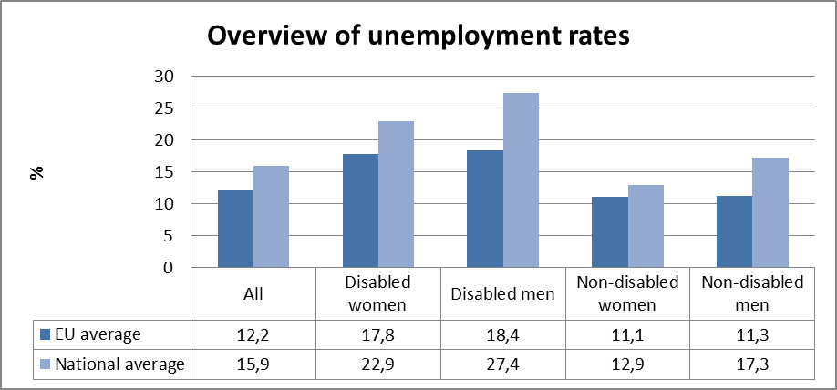
Source: EUSILC UDB 2012 – version 2 of August 2014

Table 8: Unemployment rate data, by age group
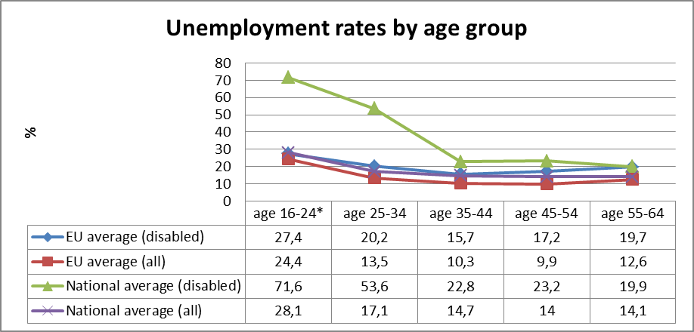
Source: EUSILC UDB 2012 – version 2 of August 2014

Alternative data on disability and unemployment from national sources:
The Law on Support for Employment (No X-694 - latest editing 10 July 2014, in Lithuanian only) encompasses the monitoring of the labour market, general services in support of occupation (information, consultation, mediation, individual activity planning), active means of labour market policy (supportive employment, rotation of work, support to create new workplaces, education of unemployed).
Article 5. Institutions Implementing the Employment Support Policy and Social Partners. The employment support policy shall be implemented by:

- the Government;
- the Ministry of Social Security and Labour and other ministries;
- other state institutions and agencies;
- municipal institutions and agencies;
- other legal and natural persons.

The Lithuanian Labour Exchange (at the Ministry of Social Security and Labour) and its local labour exchange offices, as well as the Lithuanian Labour Market Training Authority and its territorial labour market training and counselling offices, Youth Job Centres are the most important institutions for guaranties of the quality of employment services. They provide state aid to social enterprises in accordance with the procedures set forth in the Republic of Lithuania Law on Social Enterprises and legal acts regulating its implementation. They also organise and coordinate the provision of vocational rehabilitation services in accordance with the procedure set forth in the Republic of Lithuania Law on Social Integration of the Disabled and participate in the development of vocational rehabilitation programs (Chapter 2, Article 8) for disabled people. Other legal and natural persons (and also branches of enterprises and organisations, which were founded in the states that have signed the Agreement on the European Economic Area, in the Republic of Lithuania) may provide general employment support services and submit proposals to institutions implementing the employment support policy concerning the implementation of these services (Chapter 2, Article 10). It's (the last one) is more and more active in the positive processes of employment of youth with special educational needs (including disabled).

In the Law on Vocational Education (No VIII-450 - latest editing 20 June 2014, in Lithuanian only) is a very important article: vocational guidance shall be carried out in schools of general education, vocational training establishments, centres for vocational guidance, labour exchanges in accordance with the procedure laid down by the Minister of Education and Science together with the Minister of Social Security and Labour ("Guidance for All" - equivalent of "School for All" or inclusive school).

In detail (from quantitative and qualitative data): Lithuania: National Reform Programme 2014 (in English):

Reducing Unemployment (p. 9):
Tackle high unemployment amongst low-skilled workers as well as long-term unemployment. The long-term unemployment rate has been decreasing each year in Lithuania: in 2011 it accounted for 8.0 percent, in 2012 – for 6.6 percent. In accordance with data of Statistics Lithuania, in 2013, the long-term unemployment rate amounted to 5.1 percent and was 1.5 percentage point lower than in 2012.

For solving the long-term unemployment problem, the project Assistance in Finding Employment, the aim of which is to speed up the process of return of the long-term unemployed and those who are at risk of long-term unemployment to the labour market and their staying therein, was started in the end of 2013 (the project value is LTL 31.5 million, number of participants – 6 450 unemployed).

Improve the employability of young people, for example through a Youth Guarantee (p. 11-12). The unemployment rate of young people (aged 15-24) decreased by 4.8 percentage points in 2013 and accounted for 21.9 percent. There were 27.4 thousand unemployed 15-24 year olds and, as compared to 2012, their number decreased by 4.8 thousand, or 14.9 percent.

Intensive Assistance Programme for Unemployed Young School Drop-outs was approved by the Order of the Minister of Social Security and Labour of 17 April 2013. Under this programme, the project Trust in Yourself was started at the end of 2013. In order to encourage the inclusion of socially disadvantaged young people into the labour market and/or educational system, the expansion of the scope of services of youth employment centres is planned by adding services of the organisation of social rehabilitation and preparation for employment in the labour market for young people registered and not registered with Labour Exchanges. The target group of the project is 16-25 year olds, who do not work, do not study and are not engaged in active labour market policy measures; 2 thousand young people are planned to be included in the project, the project value is LTL 4 million.

11 youth employment centres (there is a total of 22 youth employment centres operating in the country), which help young people to get a better understanding of social and labour environment, solve their employment problems on their own, were opened under local Public Employment Service (Labour Exchanges) in 2013 (it is planned to establish youth employment centres in each municipality).

A plan for the implementation of Youth Guarantee was approved by the Minister of Social Security and Labour on 16 December 2013. This document aims to ensure that all young people under 29 years old receive a job offer, continue studying, including apprenticeship, or get a practice or internship within four months after losing a job or completing formal learning.

Review the appropriateness of labour legislation with regard to flexible agreement conditions, dismissal provisions and flexible working time arrangements in consultation with social partners, including and non-government organisations of disabled (p. 12-13). Review of labour legislation related to flexible employment agreement conditions, dismissal provisions and flexible working time arrangements was carried out and draft amendments to laws were prepared in consultation with social partners.

More information in 5.1.2. Fostering Employment (p. 46) in Lithuania: National Reform Programme 2014 (in English)

The project "Lithuanian social model, covering employment, industrial relations and the improvement of the sustainability of social security, the creation" is carried out by the Human Resources Development Operational Programme 4 of the measure of Public policy reform promotion project. The project focuses on the development of labour law, employment and social security legislation and the creation of a single, cost-based and balanced relationship of the system in order to increase employment improve labour relations and promote investment (Vilnius University, Mykolas Romeris University). About project in Lithuanian: http://www.socmodelis.lt/apie-projekta-2/

Economic activity

Table 9: Most recent economic activty data, aged 20-64
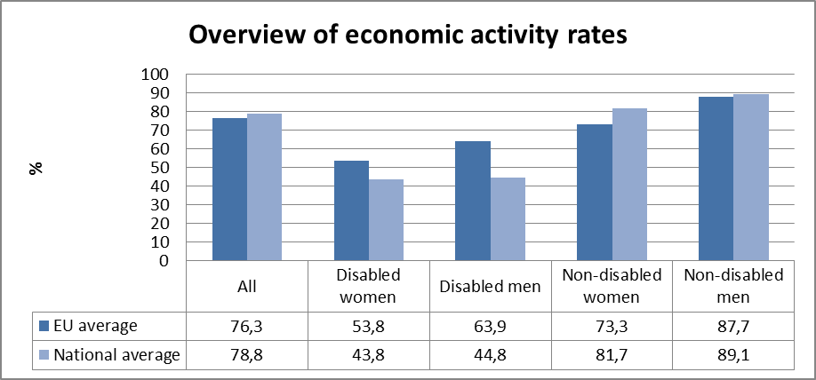
Source: EUSILC UDB 2012 – version 2 of August 2014

Table 10: Activity rate data, by age group
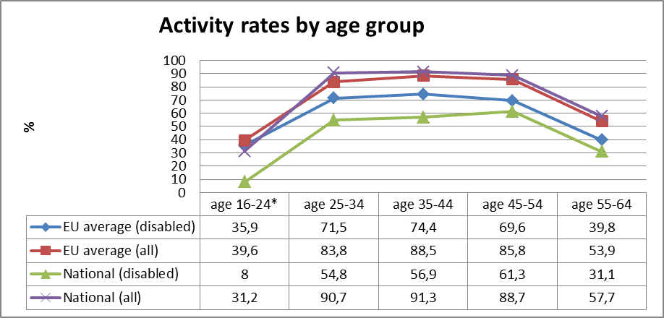
Source: EUSILC UDB 2012 – version 2 of August 2014

Alternative data on disability and economic activity from national sources:
In 2013, the employment rate and the number of employed people grew. According to the data of a Labour Force Survey performed by Statistics Lithuania, in 2013 employment rates among citizens aged 15-64 reached 63.7%, which is 1.7 percentage points less if compared to the previous year. In 2013, the male employment rate amounted to 64.7% among men aged 15–64, and the number of working women reached 62.8%, whereas both rates increased by 2.5 and 1 percentage points respectively. In 2013, the employment rate among citizens aged 55–64 increased by 1.7 percentage point and amounted to 53.4%. (Social Report 2014 - http://www.socmin.lt/en/social-report.html )

In I Quarter 2014, the total number of employed residents reached 1 million 295 thousand. Compared to the same period of 2013, this number increased by 28.1 thousand (2.2%).

Employment rate, %
 |  |  |  |  | 2013 |  |  | 2014
 |  | 2013 |  |  |  |  |  | 2014
 |  | 2013 | I quarter | II quarter |  | III quarter | IV quarter | I quarter
 | Total rate | 63.7 | 62.3 | 63.8 |  | 64.5 | 64.3 | 64.2
 | (15-64 years) | 63.7 | 62.3 | 63.8 |  | 64.5 | 64.3
 | male | 64.7 | 62.7 | 64.3 |  | 66.1 | 65.8 | 64.9
 | female | 62.8 | 62.0 | 63.3 |  | 63.1 | 62.9 | 63.6
 | Youth (15–24 years) | 24.6 | 23.5 | 24.1 |  | 25.9 | 24.9 | 25.9
 | Older age (55-64 years) | 53.4 | 52.4 | 52.6 |  | 53.9 | 54.6 | 55.1
Data of Statistics Lithuania

In the implementation of the priority measure of the implementation of Government of the Republic of Lithuania Programme 2012–2016, the Programme for the Increase of Employment 2014–2020 was adopted in 2013 by Resolution No. 878 of 25 September 2013 of the Government of the Republic of Lithuania. It is aimed at the integrated solution of current problems of residents’ employment by uniting business, education and labour market sectors as well as by engaging social partners and municipalities into the process of employment policy formation. The programme specifies the main aims (to encourage the establishment of job vacancies and labour demand, to increase the correspondence of labour force qualification to labour market needs, to integrate free labour resources into the labour market and to maintain them there) and the tasks to achieve these aims. An Inter-Institutional Action Plan aimed at achieving the aims and tasks as well as the planned results was drafted and approved by Resolution No. 204 of 26 February 2014 of the Government of the Republic of Lithuania (Social Report 2014 - http://www.socmin.lt/en/social-report.html ).

On 22 June 2013, the Council of the European Union submitted the Recommendation on the implementation of the Youth Guarantee initiative (hereinafter referred to as the YGI) (2013/C 120/01). In summer 2013, the working group drafting the Employment Programme submitted offers for employment increase covering the issues of the YGI Implementation, apprenticeship, training and practice dissemination. In autumn, the working group of the Ministry of Social Security and Labour together with youth organisations drafted an YGI implementation plan. The YGI implementation plan was approved by Order No. A1-692 of 16 December 2013 of the Minister of Social Security and Labour and submitted to the European Commission. With regard to the remarks submitted by the European Commission, the YGI implementation plan was edited providing for LTL 510.8 million for the measure financing, i.e. LTL 91.4 million less than it was specified in the plan submitted to the European Commission in December 2013 (LTL 602.2 million). A thorough analysis of target groups of participants and measures applicable to them was performed; the choice of a group of participants, i.e. youngsters under 29 years of age, was grounded; an explanation with regard to the newly developed Information and Monitoring System, which will be used to identify youngsters aged 14–29, who do not study, work and are not registered in the database of the Lithuanian Labour Exchange, was submitted; the way to ensure cooperation between governing authorities, social partners, youth organisations and other concerned entities at the national and local level was presented in detail; a mechanism aimed at ensuring the monitoring of results was specified (Social Report 2014 - http://www.socmin.lt/en/social-report.html ).

The National Programme for Social Integration of the Disabled 2013–2019 and its action plan was being implemented in 2013. 420 social rehabilitation service projects for the disabled in communities were selected in all municipalities in a tender procedure. In the implementation of the projects, funding was allocated for activities and services in line with social rehabilitation of permanent nature. 41 000 disabled person benefited from the implementation of the National Programme for Social Integration of the Disabled for 2013–2019 and its action plan in 2013. In 2013, 896 persons took part in the vocational rehabilitation programme, of which 317 persons were sent to the programme in 2012 and 579 in 2013. Employment rate within 6 month from the completion of the programme was 61 percent. Works of housing adaptation for the disabled were carried out in 56 municipalities in 2013. 200 apartments are planned to be adapted to meet the needs of the disabled in 2014. 1 478 buildings important for the disabled were approved and accepted in 2013. The approval of acceptance of 1 500 buildings important for the disabled is planned in 2014. In 2013, 1 080 disabled people studying in high schools received financial assistance. 930 disabled people studying in high schools are planned to receive financial assistance in 2014. (Lithuania: National Reform Programme 2014).

Education data

EU statistical comparisons are more limited concerning the education of young women and men with disabilities in the EU2020 target age groups.
Data is available from EU-SILC (annually) as well as the Eurostat Labour Force Survey ad-hoc disability module (for 2011), but with low reliability for several countries on the key measures. Using wider age range can improve reliability but estimations by gender remain indicative. EU trends are evident but administrative data may offer more reliable alternatives to identify national trends, where available.

Early school leavers

The EU-SILC sample for the target age group (aged 18-24) includes the following number of people reporting activity ‘limitation’ (as a proxy for impairment/disability).

Table 11: EU-SILC sample size in the target age group 18-24
 | No activity ‘limitation’ | Activity ‘limitation’ | Women reporting ‘limitation’ | Men reporting ‘limitation’
EU sample | 37,438 | 2,693 | 1,338 | 1,355
National sample | 1.076 | 48 | 21 | 27
Source: EUSILC UDB 2012 – version 2 of August 2014

Table 12: Early school leavers aged 18-24 (indicative based on above sample size)
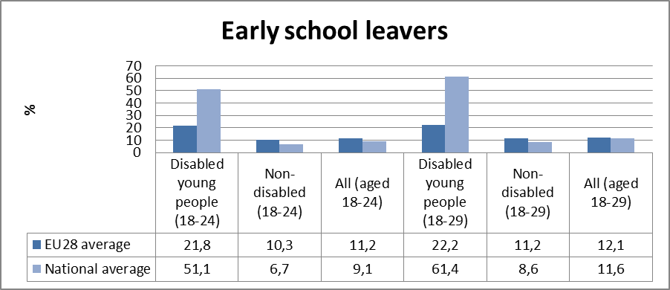

Alternative data on disability and early school leavers from national sources:
4.2. Reducing the Number of Early School Leavers (p. 24)
The aim is to reduce the proportion of 18-24 year-old early school leavers to no more than 9 % in Lithuania. This indicator was 7.9 percent in 2010, 7.4 percent in 2011, 6.5 percent in 2012 and 6.3 percent in 2013. Large gaps remain between urban and rural areas (4.8 and 12.4 percent respectively in 2011, 3.7 and 11.7 percent in 2012 and 3.6 and 11.4 percent respectively in 2013). The main causes for such increasing regional differences are believed to be inadequate school network, underdeveloped infrastructure of educational support, and insufficient qualifications and competences of teachers. (Lithuania: National Reform Programme 2014).

Tertiary education

The EU-SILC sample for the target age group (aged 30-34) includes the following number of people reporting activity ‘limitation’ (a proxy for impairment/disability).

Table 13: EU-SILC sample size for the target age group 30-34
 | No activity ‘limitation’ | Activity ‘limitation’
EU sample | 25,596 | 2,801
National sample | 446 | 29

Table 14: Completion of tertiary or equivalent education (indicative based on above sample)
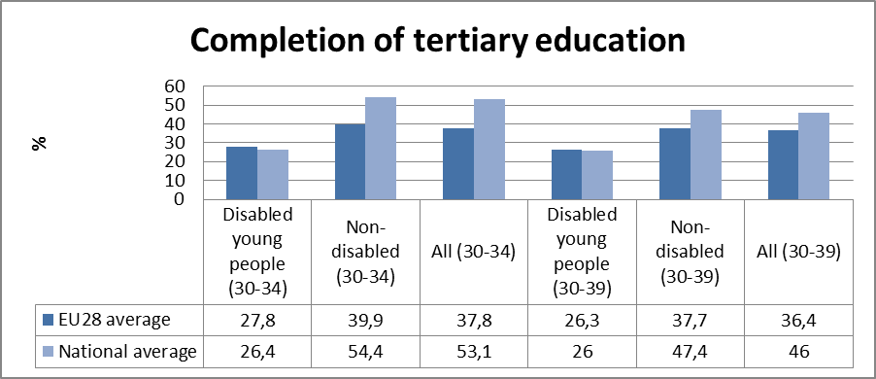
Source: EUSILC UDB 2012 – version 2 of August 2014

Alternative data on disability and tertiary education from national sources:
4.3. Retaining the Share of Individuals with Higher or Equivalent Education (Lithuania: National Reform Programme 2014, p. 26)
In Lithuania, the share of the population aged 30-34 having completed university education is increasing every year: in 2010, it was 43.8 percent, in 2011 – 45.7 percent, in 2012 – 48.6 percent and in 2013 – 51.3 percent. Lithuania aims to achieve that by 2020 at least 48.7 percent of the population aged 30-34 would have a higher or equivalent education. Since more and more young people seek higher education, a need for devoting more attention to the quality of education has recently emerged. This would lead to a higher education level among the population.

There is an aim to grow exponentially and increase people with disabilities studying in higher education (colleges and universities), but the exact number is hard to say, because the idea of “School for all” assimilates all students. This has both positive and negative aspects: everyone has the right to choose, to use the opportunities offered by the law.

Poverty and social exclusion data

EU SILC data provides indicators of the key risks for people with disabilities. In addition to household risks of low work intensity, there are risks of low income (after social transfers), and material deprivation. These three measures are combined in the overall estimate of risk. The risks for older people do not include work intensity (Eurostat refers to the age group 0-59 for this measure). The survey does not distinguish ‘activity limitation’ (the proxy for impairment/disability) for children under the age of 16. Relevant data from national sources is added where available.

Table 15: People living in household poverty and exclusion by key risk (aged 16-59)
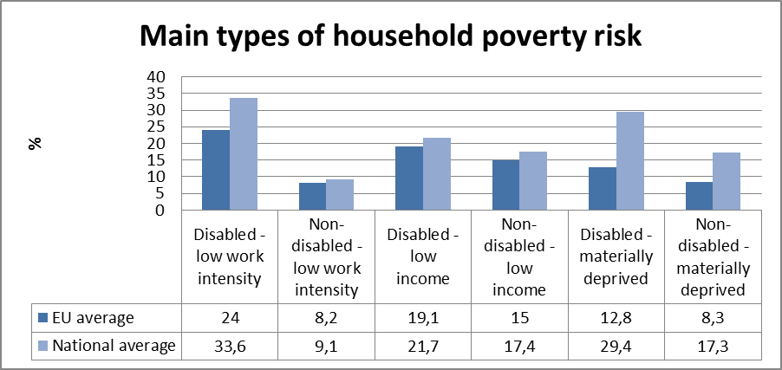
Source: EUSILC UDB 2012 – version 2 of August 2014

Table 16: People living in household poverty and exclusion by gender and severity (aged 16+)
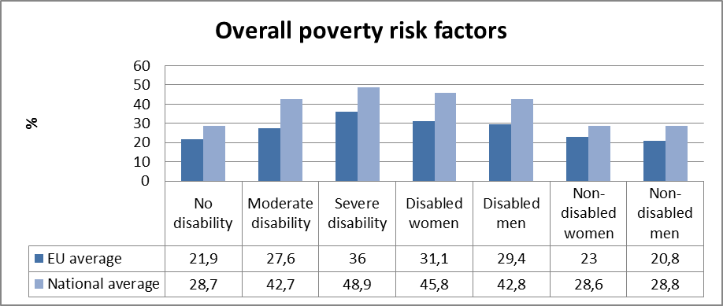
Table 17: Overall risk of household poverty by main age group (all, aged 16+)
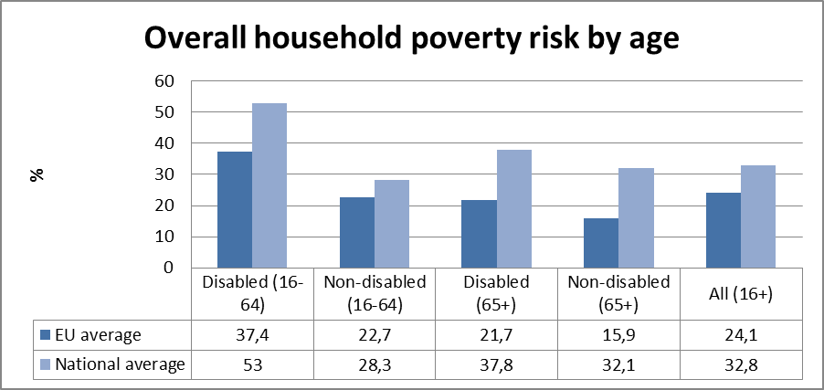
Source: EUSILC UDB 2012 – version 2 of August 2014

Table 18: Three-year trend in overall household risk of poverty and exclusion (EU-SILC 2012)
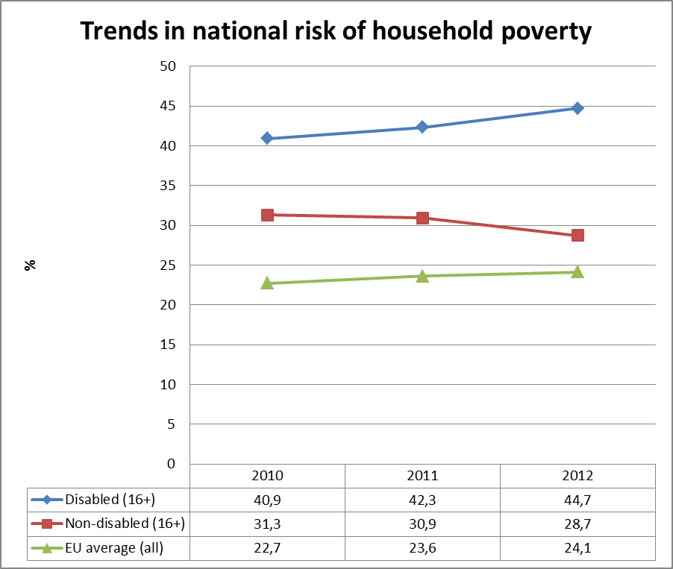
Source: EUSILC UDB 2012 – version 2 of August 2014 (and previous UDB)
Alternative data on disability and poverty risks from national sources:

Reduction of Poverty and Social Exclusion (p. 13).
Since 2014 maximum non-taxable allowance has been increased by the Law on Personal Income Tax of the Republic of Lithuania from LTL 470 to LTL 570, while due to the changed procedure of application of non-taxable allowance the progressiveness of personal income tax is increasing. Also, additional non-taxable allowance applied for the first child has been increased from LTL 100 to LTL 200 (Lithuania: National Reform Programme 2014).

Granting an additional social benefit upon employment. In order to promote the integration of the recipients of cash social assistance into the labour market, additional allocation of social benefit, which equals to 50 percent of the average social benefit amount received by them and which can be paid no longer than for 6 months, is paid to persons, who have been registered with a local Labour Exchange for at least 12 months, without considering the period of time for which they participated in active labour market policy measures or performed public works. The restraining condition allowing to pay additional social benefit only to persons raising children was waived. In order to reduce the long-term dependence on cash social benefits, the period of the receipt of social benefit has been reduced to 12 months, starting from which a benefit is reduced for working age employable but unemployed persons (their families), except for social benefit paid for children. Social benefit is not reduced also in the cases when a Lithuanian local Labour Exchange or Public Employment Service of another state did not offer a job or to take part in active labour market policy measures during the period when social benefit was paid. In order to integrate the recipients of social benefits into the labour market, according to the data of the Lithuanian Labour Exchange, in 2013 16 396 unemployed recipients of social benefits found permanent employment, 3 141 were employed for a fixed term, 7 431 obtained business licenses and 14 297 were involved in the active labour market policy measures. (Lithuania: National Reform Programme 2014).

Lithuania has particularly pressing problem rural areas, poor families, social risk families of young children (as long as they do not go to school) encompassing education, day care services. In recent years, the participation of children under 3 has increased the development of multi-function centres, expanding day care services. Social exclusion under this dimension could be associated with such instruments as a positive attitude to the elderly, the disabled strengthening through social workers and social services donor assistance. In order not to increase the integration with Disabilities employment opportunities must continue to pay attention to employers' education and motivation. And improving staff qualifications of directors to pay attention to equal opportunities, non-discrimination, recognition of diversity issues at work analysis. “Combating unemployment and poverty reduction strategies survey” (2014, July) (http://www.socmodelis.lt/wp-content/uploads/1-2-dalis-GALUTINE.pdf, in Lithuanian).

Description of the situation and trends in relation to each target area

Employment

Universal disabled rehabilitation and integration of information systems (UNRIIS in LT) - a database that has the purpose to help store, organise and disseminate the latest specialised information about people with disabilities, services, departments, facilities for disabled health, social care, education and research, employment, environment, culture, sports and other areas. It also provides various state bodies, organisations that do not have their own databases, with the opportunity to take advantage of its resources, and to provide information to the public. The database is adapted for disabled persons with various disabilities. Information in the database is freely available and free. UNRIIS main goal is to create all accessible information over the Internet, "For All" (Eng. "Design for All"), based on the principle of creation of a database, which contains relevant data for people with disabilities, as well as their rehabilitation and integration problems. UNRIIS database developed, implemented and currently oversees the functioning of the National Institute of Information Technology (SIIT), won the procurement of services. UNRIIS manager - Department by the Disabled of Social Security and Labour Ministry. More here: http://www.unriis.lt/upload/about/unriis_pristatymas.pdf (in Lithuanian only!)

This website http://www.galiudirbti.lt/en/ (in English) aims to help disabled persons find gainful employment and to assist employers in locating suitable employees. There are two parts to this website. The first is dedicated to disabled persons. This is where upon registering the users can post their CVs, edit them, and find new job offers as well as advice on finding a job and preparing for the interview. The second part of the website is meant for employers, where they can post job offers and review the CVs of the disabled persons. News, legal advice and useful links can be viewed by both groups. Galiudirbti.lt is a portal that aims to help disabled persons to find gainful employment and to assist the employers in locating suitable employees. The employers post job offers and can suggest a position to a disabled person. The disabled persons submit their CVs and can apply for positions posted on the website. On December 1, 2010 public enterprise „Union of Disabled Social Enterprises“ and their Latvian partners, association "Baltā māja"”and union "Apmācību Projekti" started implementing a project “Increasing the Competitiveness of Disabled Social Enterprises.” The project is a part of a partnership across borders program for 2007-2013.

The main purpose of this project is to increase the competitiveness of disabled social enterprises in the region of the program (part of Lithuanian and Latvian territory), which in turn would result in a larger number of employments among the disabled.

This project targets disabled social enterprises, the disabled persons, governmental institutions, and NGOs. This project seeks to study the status of the disabled and the reason for unemployment among this group in Lithuania, to prepare proposals that would encourage the integration of disabled persons into the labour market, and to research and identify those economic sectors which would be most conducive for employing the disabled. This project will also work to change the attitudes of the employers towards the disabled, to increase motivation of disabled people, to encourage networking among social partners and to publicise case studies of disabled people who have found meaningful employment as well as to promote the employment of disabled people. The public organisation „Union of Disabled Social Enterprises“ (the UDSE) was established in 2010. It is a public non-profit institution whose main objective is the integration of disabled persons in the labour market by promoting social enterprise competitiveness for people with disabilities. In our opinion, a significant proportion of people with disabilities could be employed, but that objective requires additional attention of government. Seeing rather sharp restrictions of disabled social enterprises` development and work, the UDSE is meeting and setting itself new challenges. The main task is to form a supportive and fair opinion by the public and the Government about the need to promote disabled social enterprises undertakings and successfully integrate them into the Lithuanian economy.
Lithuanian Union of people with Disabilities - http://www.negalia.lt/darbo-skelbimai/# (in Lithuanian only!) For job seeking.

Thus, since 2011, Lithuanian union of people with disabilities launched the project "Without thresholds”. It was the accessibility of object's assessment, which LŽNS personnel checked various public facilities throughout Lithuania. Information was collected and systemised. A check on the number of objects after the age during 1000 was conceived to create a web page beslenksciu.lt that every person with a disability would benefit from these data and be able to move as independently as possible in the environment. We believe that this project will be useful. More details: http://www.beslenksciu.lt/apie-projekta/ (in Lithuanian only!)

Vocational rehabilitation. Service providers (a list of the service providers in Lithuanian language); updated information on the implementation of the Vocational rehabilitation programme. The Lithuanian Labour Exchange under the Ministry of Social Security and Labour.

Education

4.2. Reducing the Number of Early School Leavers (p. 24) Lithuania: National Reform Programme 2014 (in English):
Measures being implemented include:

As from 2011 to the end of 2013, 31 non-state pre-primary education institution was established (there is a total of 67). Conditions were created for more than another 10 370 pre-schoolers to get education in state, municipal and non-state institutions under pre-school education programmes. According to the data as at the end of 2013, there was a total of 92 313 children educated under pre-school education programmes. According to the data of Q 4 of 2013 (as compared to the data of 31 December 2012), the number of children who started receiving education under pre-school education programmes in pre-school education institutions increased by 4 441 (an increase of almost 5 percent per year). Also, the number of children educated under pre-primary education programmes increased by more than 500. According to the data of December 2013, there were more than 117 700 children educated under pre-school and pre-primary education programmes;

During the implementation of the National Youth Policy Development 2011–2019, in 2013, 5 projects for entrepreneurship education of young people were being carried out in schools of the country: Implementation of Innovative Methods in the Process of Entrepreneurship Education, Practical Entrepreneurship Education Programmes Entrepreneurship Academy, Creation and Implementation of Methods of Entrepreneurship Education in Schools of Lithuania and Creative Path to Entrepreneurship. On 18 October 2013, the Minister of Education and Science approved the action plan for the Improvement of Funding of Non-Formal Education of Children, which provides for non-formal education funding trends in 2014–2016, also, the appropriateness of the EU funds, creating preconditions for further development of non-formal education of children and improvement of quality thereof. Programme for the Preparation for Family-Life and Sex Education is being implemented in schools, while in the implementation of the Law on Minimum and Average Child Care, the Programme on the Courses for Improved Communication with Children was approved and trainings on the subject of Holding Courses for Improved Communication with Children: Theoretical and Practical Aspects for municipal administrations were held. In order to evaluate and select efficient prevention programmes and implement them in schools, accreditation of prevention programmes was carried out under activities of the project Creating Safe School Environment.

In 2013, a two-part tool for teaching the Lithuanian Language Raises Me was published and distributed to primary school students studying in schools in minority languages (16 thousand copies). An educational tool FREPPY – playful language education tools (200 pcs.) was purchased and distributed to each pre-school education group studying in a minority language;

In the implementation of the ESF project Dissemination Model of Curriculum Innovations digital teaching tools for native Polish, Russian, Belarussian languages for 9-12 grade students were developed in 2013. Methodical tools for teaching the Polish, Russian and Belarussian languages, also material for getting familiar with the Roma, Jewish history were prepared;

The National Education Strategy 2013–2022, the aim of which is to make sure that the Lithuanian education forms a foundation for an impetuous and independent person responsibly and jointly and severally creating his own future as well as the future of the country and the entire world, was approved in 2013;

In 2013, statistical analysis of the Lithuanian language and literature was conducted, on the basis of the results of which the preparation of evaluation norms for 2014 is planned, creating a different evaluation system of literacy and style of students from minority language schools.

4.3. Retaining the Share of Individuals with Higher or Equivalent Education (p. 26) Lithuania: National Reform Programme 2014 (in English):
Measures being implemented include:

For the implementation of the Programme for the National Vocational Guidance within Education System, 4 EU Structural Fund project activities for strengthening the methodological base (training programs, methodologies and other tools) for vocational guidance (career) services, training of career specialists, provision of services, arrangement of service monitoring as well as improvement of infrastructure were being implemented since 2012. The provision of vocational guidance (career) services of high quality was started to pupils and students in general education schools, vocational training institutions and universities;

General programme for career education for general education schools and vocational training institutions as well as methodical tools were prepared;

During the implementation of the project Development of Open Information, Counselling and Guidance System (AIKOS), educational registers providing data to the system were updated;

Activity under the project Development and Implementation of Models for Career Education of Students of Schools of Higher Education and Career Tracking of Graduates, Creation of Necessary Tools (Stage II) is being completed;

LAMA BPO system is undergoing further development (as from 2014, information in the English language will also be provided, curriculum database will be associated with programme accreditation database);
Initial analysis of data of the Specialist Qualifications Map is being prepared, the data of which will be used in planning the training of specialists and determining student enrolment rates in subsequent years.

Poverty and social inclusion

4.8. Reducing Poverty and Social Exclusion (p. 37-39) Lithuania: National Reform Programme 2014 (in English):
Measures being implemented:
In October 2013, the action plan* for Increasing Social Inclusion 2014–2020, the main focus of which is children and young people, was prepared and approved. The action plan provides for investments into accessibility of pre-school and non-formal education, activities of child day-care centres, provision of comprehensive services, social work with children in foster care, employment enhancement measures for young people. Also, a large share of measures provided for in the action plan for Increasing Social Inclusion 2014–2020 are aimed at the development, renovation and improvement of public service system and infrastructure, improvement of skills of service providers, inclusion of service users and non-governmental sectors into decision-making and service provision. The action plan for Increasing Social Inclusion 2014–2020 lists quantitative goals for the reduction of poverty and social exclusion, which will form the basis for the evaluation of the action plan implementation results.

The development of services for families was being continued in 2013 involving in it non-governmental organisations and making communities more active. In 2013, in the implementation of the Child Welfare Programme 2013–2018, comprehensive services for parents in crisis situations raising children were provided for 807 families raising 1 087 children. There was a total of 1 999 of the recipients of such services.

The implementation of 2011–2013 action plan for the National Youth Policy Development Programme 2011–2019 was aimed at the development and coordination of the system for working with young people and ensuring cooperation between various social sectors. In 2013, 12 open youth centre projects and 13 open youth space projects were funded for the achievement of operational quality of youth organizations, promotion of youth entrepreneurship and the development of open youth centres and open spaces. The promotion of national and regional youth structures, also youth organisations was continued in 2013 – 60 programmes and projects aimed at strengthening youth organizations and organizations working with young people were financed. The National Youth Volunteering Programme, the aim of which is to enable young people to participate in voluntary activities and gain personal, social, professional skills and work experience, was approved in the beginning of 2013.

Non-governmental organisations working in the field of family welfare will be financed when implementing the National Demographic (Population) Strategy. 22 projects were funded in 2013. During the implementation of the projects, 259 families and 700 individuals received psychological consultations, while 759 families and 2 821 individuals were provided with social consultation services. Project implementers held 5 603 events of different nature (educational, group classes, lessons, trainings, information, entertainment events) for families, engaged couples and individuals.

The National Programme for Social Integration of the Disabled 2013–2019 and its action plan was being implemented in 2013. 420 social rehabilitation service projects for the disabled in communities were selected in all municipalities in a tender procedure. In the implementation of the projects, funding was allocated for activities and services in line with social rehabilitation of permanent nature. 41 000 disabled person benefited from the implementation of the National Programme for Social Integration of the Disabled for 2013–2019 and its action plan in 2013. In 2013, 896 persons took part in the vocational rehabilitation programme, of which 317 persons were sent to the programme in 2012 and 579 in 2013. The employment rate within 6 months from the completion of the programme was 61 percent. Works of housing adaptation for the disabled were carried out in 56 municipalities in 2013. 200 apartments are planned to be adapted to meet the needs of the disabled in 2014. 1 478 buildings important for the disabled were approved and accepted in 2013. The approval of acceptance of 1 500 buildings important for the disabled is planned in 2014. In 2013, 1 080 disabled people studying in high schools received financial assistance. 930 disabled people studying in high schools are planned to receive financial assistance in 2014.

In the implementation of the Programme of Social Development of Communities 2011–2013, works in two directions were being carried out: capabilities of non-governmental organisations to provide social innovation-based public services were strengthened and mutual cooperation of organizations as well as their cooperation with municipalities was promoted. In 2013, 81 social activity projects of community organizations was funded, 5 regional community forums aimed at the development of social entrepreneurship and promotion of innovative ideas were held. In 2013, activities of organisations representing elderly people aimed at enhancing the expansion of voluntary activities of non-governmental organisations representing elderly persons and strengthening the impact of these organisations, were supported.

In 2013, in order to increase the cohesion of social, cultural and health areas, 14 projects contributing to the enhancement of positive impact of arts on human health and social welfare as well as improvement of quality of life were partially funded and implemented. Activities of these projects were carried out in institutions providing health care and social services.

In the implementation of the Health Care System Reform Continuity and Health Care Infrastructure Optimization Programme, municipal personal health care institutions providing specialised outpatient, day surgery, admission – emergency, nursing and therapy services, also municipal public health offices were modernised.

356 jobs were created during the implementation of the projects of local employment initiatives, 4 257 people engaged in individual activities under a business licence were granted subsidies in the implementation of self-employment programmes of the unemployed.

Public infrastructure and environment was arranged in 106 rural areas. The arrangement of 244 places is planned for in the end of 2015 in accordance with the contracts under execution.

Assessment of policies in place to meet the relevant headline targets

Employment

Lithuania: National Reform Programme 2014 (in English):
4.7. Increasing Employment (p. 36-37).

Planned works:

- To organise and provide professional consultation and motivation services for job seekers, provide professional consultation and motivation services personally or to groups of people, improve the accessibility and quality of professional consultation services, apply new consultation measures;
- To implement the Youth Guarantee Initiative and other comprehensive programmes promoting youth employment. Improve the accessibility and quality of professional guidance (career) services. To promote self-employment and entrepreneurship;
- By matching labour supply and demand, to support the integration of the unemployed into the labour market (vocational training, assistance for job creation);
- To support employment of young persons, long-term unemployed, low-skilled persons and people older than 50 years of working age. To create and implement long-term social rehabilitation and preparation for employment in the labour market assistance system;
- To prepare and implement career competence development programme, organise trainings using modern information technologies for specialists and those working with young people;
- To create a data bank of students wishing to work during their summer holidays and inform employers about that;
- To increase the coverage of youth employment centres;
- To send low-skilled young people to study under primary labour market and vocational training programmes of general education;
- To increase participation of the disabled in the labour market;
- To allow returning emigrants to integrate in the labour market;
- To improve the quality of services of authorities implementing the employment support policy;
- To create and develop models of career education and monitoring in the areas of general education and vocational training;
- To create and develop the system for monitoring employment and careers of high school graduates. To prepare reviews and recommendations based on the data of qualifications map and career management information system on determining student enrolment indicators, professional training and career service development in high schools;
- To draw up new and update the existing descriptions of study areas (groups of areas, fields);
- To promote and modernize vocational training, ensure that it matches needs of the labour market;
- To create a tool for forecasting demand for human resources and monitoring qualification matching with jobs;
- To improve the qualifications of human resources, increase their competence and develop labour force skills;
- To prepare and implement the system for formalising skills acquired in a non-formal, work or self-education environment, develop competence evaluation system;
- To implement life-long learning incentives;
- To make the system of qualification development of vocational teachers working in vocational training institutions, create and implement the scheme for the integration of graduates in the labour market (internships, etc.);
- To direct domestic investments to regions, implement local employment initiative projects in territories of highest unemployment;
- To provide assistance to budding entrepreneurs;
- To allow target youth groups (for example, vocational school graduates, high school graduates from technological programmes, etc.) to receive assistance from financial institutions operating in Lithuania, venture capital funds, co-investment fund representatives and entrepreneurs (Business Angels), who have successfully developed businesses, also assistance from financial engineering measures;
- To support quality on-going consultation services on starting a business and trainings;
- To provide specialised consultation and training services in a voucher principle;
- To develop public access services for business;
- The preparation of the Lithuanian Entrepreneurship Action Plan for 2014–2020 is planned in 2014.

Education

4.2. Reducing the Number of Early School Leavers (p. 25-26) Lithuania: National Reform Programme 2014 (in English):

Planned works:

- Prepare an action plan aimed at strengthening primary schools and junior gymnasiums intended for the improvement of quality of primary and basic education, arranging targeted complex assistance for schools, promotion of the creation of schools – multifunctional centres, pre-school and pre-primary school education groups in schools of general education;
- Prepare an action plan for the accessibility of inclusive education, the provision of quality complex education assistance for children with special educational needs and their families, inclusion of school drop-outs and early school leavers;
- Prepare and test non-formal education targeted preventive programmes for the creation of safe schools, enhancing health of children and their social and emotional resilience and implement them;
- Approve and implement an action plan for the socialization of children and young people for 2014–2016, including the organization of summer recreation activities, reorganization of socialisation centres and other activities;
- Approve and implement an action plan for the development of vocational training for 2014– 2016, including the reorganization of vocational training institution networks, in the view of perspectives of prospects of regional industries, training vocational teachers and arrangement of their internships in actual workplaces, encouraging highly – qualified employees working in production to work as vocational teachers, student practices, initiatives promoting entrepreneurship, implementation of the European and national qualifications framework, by rearranging vocational training programmes into modular ones and the system of examination for qualification in order to have qualifications obtained in Lithuania to be equated to qualifications received in a way of formal, non-formal or self-education in European Union member states. A strategic planned goal includes the development of a modern vocational training system compliant with the needs of a studying person, the public and the state. The plan provides for 9 goals aimed at the optimisation of vocational training institution network, improvement of infrastructure of vocational training institutions and the improvement of their implementation quality, enhancement of scope of training in workplaces, improvement of the assessment system of competencies for gaining qualification, improvement of management of vocational training institutions, enhancement of attractiveness of vocational training, etc.;
- Along with the preparation of an action plan for the development of vocational training for 2014–2016, a draft amendment to the Law on Vocational Training of the Republic of Lithuania is being prepared, its implementing legislation is being reviewed. Amendments to these laws are directly related to and affect the measures provided for in the action plan.

4.3. Retaining the Share of Individuals with Higher or Equivalent Education (p. 27) Lithuania: National Reform Programme 2014 (in English):

Planned works:

In 2014, the implementation of the measures of the 2013–2015 action plan of the 2013–2020 Programme of the State Higher Education, Research and Experimental (Social, Cultural) Development aimed at ensuring informed and conscious choice and that the availability of studies approved by the Minister of Education and Science on 25 June 2013 will be continued.

Poverty and social inclusion

4.8. Reducing Poverty and Social Exclusion (p. 39-40) Lithuania: National Reform Programme 2014 (in English):

Planned works:

- To get ready for the implementation of the prepared Regulation of the European Parliament and of the Council on the European aid to the most deprived persons and to provide food assistance to about 300 thousand persons;
- In 2014, the development of services for families will be continued by involving non-governmental organisations and activating communities. In the implementation of the measures of the Child Welfare Programme 2013–2018, the expansion of child day care centres in municipalities is planned for in 2014, by providing non-institutional day care services for children and families. Larger funding amount is planned for this purpose;
- Successful activities in order to increase the number of children raised in foster families rather than in institutions will be continued: searches for foster parents (care givers) and adopted parents will be held, services and assistance for their preparation, selection and consultation will be provided. Comprehensive services for families in a crisis situation will be developed;
- Action plan for the implementation of the National Demographic (Population) Policy Strategy in the Field of the Family Welfare aimed at the implementation of goals and tasks established in the National Demographic (Population) Policy Strategy is planned to be prepared and approved in 2014;
- In 2014, the National Programme for the Prevention of Violence in Immediate Environment and Assistance for Victims of Domestic Violence for 2014–2020 will be prepared and approved;
- Projects for social rehabilitation of the disabled in communities selected in a tender procedure will be funded in 2014. The plan is that 40 thousand disabled persons will benefit from the implementation of the measures in 2014. The provision of vocational rehabilitation services to the disabled will be continued in 2014. The plan is to have 400 persons sent to vocational rehabilitation programme in 2014, of which 50 percent are planned to find employment within 6 months from the completion of the programme;
- Action plan for the Development of Non-Governmental Organizations and Communities 2014–2016 will be prepared in 2014. LTL 1 million is planned to be allocated for the implementation of the action plan;
- Setting of more favourable conditions for families (persons) to acquire housing, provision of state-funded housing credits and establishment of compensation of a part of costs incurred for the rent of housing leased on the market or of lease expenses for families (individuals) entitled to social housing are planned for in 2014,
- Project of cultural activities aimed at socially excluded groups, large families, seniors, children and young people will be continued in 2014; projects enhancing positive impact of arts on human health and social welfare will be funded; the aim will be to adapt non-traditional spaces for the provision of cultural services in regions and to form alternative cultural spaces in city districts.

Assessment of progress/ problems:
Quite significant progress was made in the area of the reduction of poverty and social exclusion by implementing cash assistance system reform. In the implementation of the cash social assistance system reform and in the view of the fact that the results of pilot project in 5 municipalities proved to be worthwhile, it was decided in 2013 that as from 2014 all municipalities will take over the payment of cash social benefits as an individual payment function.

Increase of income - the minimum monthly wages - by 17.7 percent from LTL 850 to LTL 1000 had the greatest effect on declining risk of poverty on working persons in 2013.

Social consequences of crisis, which have resulted in a relatively high number of social cash assistance recipients, remain a problem; the number of recipients increased 5 times in 2013, compared to the pre-crisis period (2007).

Synergies between developments in the different areas

Lithuania: National Reform Programme 2014 (in English): Chapter VI. INTERINSTITUTIONAL COOPERATION AND INCLUSION OF SOCIAL AND ECONOMIC PARTNERS.

The Ministry of Economy has informed in writing public organisations representing various interest groups, social and economic partners (Tripartite Council of the Republic of Lithuania, the Lithuanian Business Employers' Confederation, the Association of Lithuanian Chambers of Commerce, Industry and Crafts, the Lithuanian Confederation of Industrialists, the Lithuanian Trade Union Confederation, the Lithuanian labour federation, the Lithuanian academy of sciences, the Lithuanian Business Confederation ICC Lietuva, Association of Lithuanian Banks, Association Investors’ Forum, Association of Local Authorities in Lithuania, the Lithuanian National Union of Students, Non-Governmental Organisations' Information and Support Centre, the Lithuanian renewable resources energy association, the Lithuanian energy consultants association) about a planned update of the National Reform Programme 2014 and proposed that they provide their offers for the achievement of the Europe 2020 Strategy goals.

During its preparation, the draft National Reform Programme 2014 was uploaded on the website of the Ministry of Economy, and all interested persons and institutions could provide their comments thereon. The proposals received were partially taken into account.

On 25 March 2014, the draft National Reform Programme was presented in the meeting of the Tripartite Council (Economic Social Council) of the Republic of Lithuania. The Tripartite Council consists of the Government of the Republic of Lithuania, representatives of employers’ and trade union confederations. After the presentation, discussions were held on the issues of social policy and fostering competitiveness.

Follow-up of the disability perspective in the European semester

Progress on disability issues in the Country Specific Recommendations (CSRs)

COUNCIL RECOMMENDATION, of 8 July 2014 on the National Reform Programme 2014 of Lithuania and delivering a Council opinion on the Convergence Programme of Lithuania, 2014 (2014/C 247/13):
http://ec.europa.eu/europe2020/pdf/csr2014/csr2014_council_lithuania_en.pdf
(...)
- On 13 November 2013, the Commission adopted the Annual Growth Survey, marking the start of the 2014 European Semester for economic policy coordination. Also, on 13 November 2013, the Commission, on the basis of Regulation (EU) No 1176/2011 of the European Parliament and of the Council (¹), adopted the Alert Mechanism Report, in which Lithuania was not identified as one of the Member States for which an in‐depth review would be carried out.
- ...
- On 1 April 2014, Lithuania submitted its 2014 National Reform Programme and on 22 April 2014 its 2014 Convergence Programme. In order to take account of their interlinkages, the two programmes have been assessed at the same time.
- The objective of the budgetary strategy outlined in the 2014 Convergence Programme is to reach the medium‐term objective by 2015 and to achieve a structural surplus of 0,9 % of GDP at the end of the Convergence Programme in 2017. (…) Based on its assessment of the Convergence Programme and the Commission forecast, pursuant to Regulation (EC) no. 1466/97, the Council is of the opinion that there is a risk of a significant deviation from the adjustment path towards the medium term objective as of 2014.
- ...
- Unfavourable demographic developments cast doubts on Lithuania's long‐term fiscal sustainability. Pension spending is projected to increase substantially and is estimated, over 50 years, to reach almost double the EU average. (…)
- ...
- Despite recent improvement, working‐age poverty remains above the EU average. Increases in the mini mum monthly wage and non‐taxable threshold have helped to address poverty (…) Lithuania adopted the 2014‐2020 Action Plan for Enhancing Social Inclusion. However, there remains a need to establish the main target groups, the budget and concrete measures, specifying how the targets will be achieved and how the various ministries, local governments and civil society actors implementing.
(...)
HEREBY RECOMMENDS that Lithuania take action within the period 2014‐2015 to:
(3) Better target active labour market policy measures to the low‐skilled and long‐term unemployed. Improve coverage and adequacy of unemployment benefits and link them to activation (…)
(4) Ensure adequate coverage of those most in need and continue to strengthen the links between cash social assistance and activation measures.

COMMISSION STAFF WORKING DOCUMENT, Assessment of the 2014 national reform programme and convergence programme for LITHUANIA. Accompanying the document. Recommendation for a COUNCIL RECOMMENDATION on Lithuania’s 2014 national reform programme and delivering a Council opinion on Lithuania’s 2014 convergence programme (Brussels, 2.6.2014, SWD(2014):
http://ec.europa.eu/europe2020/pdf/csr2014/swd2014_lithuania_en.pdf

Table 19: Policy measures related to achieving Recommendation #
The biggest activity at 2014 in Social policy area (http://www.socmin.lt/lt/veikla/koncepcijos-strategijos.html , http://www.socmin.lt/en/social-report.html ), then Education policy https://www.smm.lt/web/en/

Policy Measure
- Action Plan of Social inclusion for the period 2014-2020. (24 January of 2014No. A1-47). http://www.socmin.lt/download/6579/socialines%2520itraukties%2520veiksmu-planas.pdf+&cd=2&hl=lt&ct=clnk&gl=lt (in Lithuanian)
- Annual Growth Survey 2014 (annexes: Single Market Integration report, Joint Employment Report, Staff Working Document)
- FORMAL ADULT EDUCATION LAW AMENDMENT of LAW No. VIII-822 (10 July of 2014, Nr. XII-1018, Vilnius) (in Lithuanian)
- Lithuania: National Reform Programme 2014 (Vilnius, 2014) http://ec.europa.eu/europe2020/pdf/csr2014/nrp2014_lithuania_en.pdf
- LITHUANIA’S PROGRESS STRATEGY “LITHUANIA 2030” (15 May, 2012, Nr. XI-2015 Vilnius) http://www3.lrs.lt/pls/inter3/dokpaieska.showdoc_l?p_id=425517&p_query=&p_tr2=2 (in Lithuanian)
http://lietuva2030.lt/images/stories/en_lietuva2030.pdf
- LIST OF PROGRESS ACTIONS FOR 2014 http://lietuva2030.lt/images/stories/pa_for_2014_english.pdf
- NATIONAL PROGRAMME of SOCIAL INTEGRATION OF PERSONS WITH DISABILITIES 2013-2019 (in Lithuanian)
- The Programme of Increasing Employment for 2014-2020. (25 September, 2013 Nr. 878, Vilnius). (in Lithuanian)
http://www3.lrs.lt/pls/inter3/dokpaieska.showdoc_l?p_id=456810&p_tr2=2
- The Social Report 2013-2014. Ministry of Social Security and Labour of Lithuania Republic (Vilnius, 2014):
http://www.socmin.lt/download/8233/en%20socialinis%20pranesimas%202013-2014%20interactive-09-15.pdf (98 pages), https://www.e-tar.lt/portal/legalAct.html?documentId=2da7fce0117411e4adf3c8c5d7681e73
- II-10 Anex for NRP. The proposals on social exclusion (poverty), priorities and measures Lithuania http://www.socmodelis.lt/wp-content/uploads/II-101.pdf (in Lithuanian)

Other CSRs (not disability-specific) with a potential disability perspective/angle

- Table No. 19
- LITHUANIA’S PROGRESS STRATEGY “LITHUANIA 2030” (15 May, 2012, Nr. XI-2015 Vilnius) http://www.lietuva2030.lt/
- UNESCO programme “Education for All 2015 OVERVIEW OF NATIONAL EDUCATION. LITHUANIA.” (2014) (128 pages)
https://www.smm.lt/uploads/documents/en_versijai/Reports/UNESCO%20Education%20for%20All%20Report%20(LITHUANIA).pdf

Assessment of disability relevant issues in the Staff Working Document (SWD)

Lithuania‘s National Reform Programme is a summary of the main structural reforms that Lithuania projects in its effort to eliminate obstacles to economic growth and achieve nationally transposed headline targets under the Europe 2020 Strategy.
The National Reform Programme has been drafted in order to implement the European Council Conclusions of 2010, the Integrated Guidelines for Growth and Jobs, the Europe 2020 Strategy and having regard to the principles of the Euro-Plus Pact approved by the European Council on 24-25 March 2011, and the context of the draft Lithuania 2030 Strategy. It is in line with the main provisions of the Convergence Programme and other strategic-programming documents currently implemented by the Government of Lithuania.
http://www.ukmin.lt/web/en/europe2020

Assessment of the structural funds 2007-2013 / ESIF 2014-2020 or other relevant funds

2007-2013 EU assistance
http://www.ukmin.lt/web/en/eu_support/2007_2013_EU_assistance
Assistance from European Union Structural Funds and Cohesion Fund has been provided to Lithuania in the programming period of 2007-2013 as well. It should be mentioned there were only two structural funds in 2007-2013 programming period: the European regional development fund and European social fund, however according to 2007-2013 structural funds regulations, the Cohesion Fund is managed under the same rules and the Cohesion fund could also be treated conditionally as structural fund. European Agricultural Guidance and Guarantee Fund, Guidance Section, and the Financial Instrument for Fisheries Guidance, after Cohesion policy reform, were integrated into the instruments under the Common agricultural policy and the Common fisheries policy; therefore these instruments are not structural funds anymore in the programming period of 2007-2013.

European Union structural assistance in 2007-2013 is provided under base of different documents compared to 2004-2006 period. SPD is replaced by several strategic documents on structural assistance:

- National strategic reference framework: the Lithuanian Strategy for the use of European Union Structural Assistance for 2007-2013 – Strategy defines primary areas of EU structural assistance;
- Four operational programmes for implementation of this strategy - these programmes define particular intervention areas. Operational programmes are aiming to achieve the objectives set up in the aforementioned strategy.

National strategic documents are in full compliance with:
- EU structural assistance priorities, which are specified in the Community strategic guidelines on cohesion;
- Lithuanian long-term strategies.

EU structural assistance is provided under new EU regulations, which could be found here.
- Operational Programme for the Development of Human Resources for 2007–2013,
- Operational Programme for the Economic Growth for 2007–2013
- (Description of structural assistance areas Ministry of Economy is responsible for),
- Operational Programme for Promotion of Cohesion for 2007–2013
- (Description of structural assistance areas Ministry of Economy is responsible for),
- Technical assistance Operational Programme for 2007–2013.

Representatives from national institutions and agencies as well as other partners participated in the preparation of Operational Programmes. Drafts of Operational Programmes were submitted to European Commission and corrected in accordance with comments and proposals received. European Commission has approved all operational programmes of the Republic of Lithuania.

The investment areas under competence of Ministry of Economy during programming period of 2007-2013 are focused on business, including research & development, business environment, tourism and energy sectors.

2014-2020 EU assistance http://www.ukmin.lt/web/en/eu_support/2007_2013_EU_assistance
Before 2020, major focus and support will be given to research, development and innovation R&D&I (about LTL 1.2 billion), small and medium-sized business development (about LTL 1.84 billion), the enhancement of energy efficiency of industrial enterprises (LTL 80 million), the dissemination of information related to natural and cultural objects (LTL 120 million) and the increase of competence of human resources (LTL 384 million).

The support for R&D&I will cover the most important areas like research, development and innovation, the promotion of clustering, the promotion and spread of innovation, the attraction of foreign direct investment and the enhancement of demand for innovation.

The new financial period will be different from the previous ones as the support under business instruments will be exclusively granted to small and medium-sized business. In 2014-2020, more of the EU structural support will be granted through financial instruments rather than subsidies. Another distinctive feature of the new period is access to support at more favourable terms for those companies which will be implementing projects in the regions.

In 2014-2020, the support for small and medium-sized business will be focused on the promotion of entrepreneurship, the enhancement of productivity and export (including also private tourism support initiatives) as well as the introduction of eco-innovation.

In addition, considerable focus will be placed on investment through financial instruments (loans, guarantees, risk capital funds, etc.) as this support granting approach is less likely to distort competition. Moreover, this generates the return of funds which may be re-invested in other companies.

During the new period, support to both small and large industrial enterprises will be given seeking to reduce their energy intensity, which is aimed to promote the use of renewable energy resources and the enhancement of energy efficiency of industrial enterprises as well as carrying out of energy audit and the construction of cogeneration power plants.
Unlike in 2007-2013, when the support was mainly targeted at public tourism infrastructure, in 2014-2020, the support for public tourism will be exclusively aimed to increase awareness about the objects of natural and cultural heritage. The support is planned to be focused on various tourism marketing instruments, designed to promote natural and cultural heritage objects, situated on the national tourism routes, as well as the object marking. The amount planned to be earmarked makes LTL120 million.

During the new period of the EU structural support, the Ministry of Economy will offer support for implementing projects aimed to raise and develop apprenticeship and sectorial competences as well as create the forecasting and development mechanism of the monitoring of human resources.

Lithuanian EU Council presidency http://www.esparama.lt/2007-2013/en :

- http://www.esparama.lt/2007-2013/en/operational-programmes
- http://www.esparama.lt/2007-2013/en/evaluation
- http://www.esparama.lt/2007-2013/en/financial-engineering

The international conference "Cohesion Policy 2014–2020: Towards Evidence Based Programming and Evaluation", which was organized by the Lithuanian Ministry of Finance and the European Commission's Directorate-General for Employment, Social Affairs and Inclusion took place on 4–5 July 2013 in Vilnius, Lithuania.
The conference discussions were held on programming and evaluation of EU Structural Funds in 2014–2020, including:

- new approach to the intervention logic and new requirements for programme monitoring and evaluation;
- methodological, organisational and procedural aspects of the evaluation of EU Structural Funds;
- results of ex-ante evaluations of operational programmes of the upcoming period.

This conference was one of the first Lithuanian EU Council presidency events. The conference brought together officials from Lithuania and other EU Member States, representatives of the EU institutions, responsible for programming, monitoring and evaluation of EU Structural Funds, representatives from academia, socio-economic partners and other stakeholders.

European Economic Area and Norway Grants
http://www.finmin.lt/web/finmin/eeagrants

Assistance from Switzerland
http://www.finmin.lt/c/portal/layout?p_l_id=PUB.1.204

Other EU Support
EU structural assistance for 2007–2013 is allocated from the European Social Fund, European Regional Development Fund and Cohesion Fund under the Lithuanian Strategy for the Use of European Union Structural Assistance for 2007-2013(i.e. the assistance granted totals more than LTL 23 billion).

The considerations towards the EU Cohesion Policy after the year 2013 at EU level have started from the middle of 2007. More intensive discussions and preparation for the new period of the use of EU structural assistance at EU and national levels started in the second half of 2010, when the Commission for solving the issues related to EU structural assistance for 2014–2020 was established in Lithuania and the European Commission published the Fifth Report on Economic, Social and Territorial Cohesion.

Before the EU membership and after becoming the EU Member State, Lithuania participates in various European Community programmes in order to support the cooperation among the EU Member States in various specific fields related to the policy of the European Communities.

ETBT – EU Territorial Cooperation projects with neighbours (Latvia, Poland), INTERREG, Baltic sea region projects, INFOREGIO, INTERACT etc.
http://www.esbendradarbiavimas.lt/index.php?id=31 http://ec.europa.eu/regional_policy/information/panorama/index_lt.cfm

Use of funds in relation to disability challenges

Grants for disabled people are included in ESIF, or other projects.

Preparations for ESIF 2014-2020

Summary Partnership Agreement for Lithuania 2014-2020. http://ec.europa.eu/contracts_grants/pa/partnership-agreement-lithuania-summary_en.pdf

European Comission. Employment, Social Affairs and Exclusion
http://ec.europa.eu/social/main.jsp?langId=lt&catId=89&newsId=2086&furtherNews=yes (2014-06-20)

The European Commission has adopted Partnership Agreements with Cyprus, Slovakia and the three Baltic States (Lithuania, Latvia, Estonia) on the use of European Structural and Investment Funds funding during the next seven years.
In addition to funding from the European Social Fund (ESF), all these countries apart from Estonia will be allocated financial support from the Youth Employment Initiative (YEI).

Priorities
(…) Each country has its own priorities to focus on. For Lithuania helping people enter the labour market is a top priority. (…)

Budget
The total ESF allocation differs from country to country. The funding from the Youth Employment Initiative (YEI), a financial instrument to confront the high youth unemployment rates across Europe, also varies depending on the country.
The exact breakdown is given in the table below:

 | Cyprus | Lithuania | Latvia | Estonia | Slovakia
Promoting sustainable and quality employment and supporting labour mobility | € 69,500,000 | € 275,504,430 | € 135,410,788 | € 228,122,335 | € 918,099,996
Promoting social inclusion, combating poverty and any discrimination | € 27,000,000 | € 220,294,386 | € 225,160,750 | € 133,753,104 | € 433,699,291
Investing in education, training and vocational training for skills and lifelong learning | € 26,000,000 | € 455,313,921 | € 238,500,493 | € 194,889,771 | € 458,745,509
Enhancing institutional capacity of public authorities and stakeholders and efficient public administration | € 5,055,000 | € 150,359,184 | € 18,063,357 | € 30,211,800 | € 267,311,313
Technical assistance | € 1,933,887 | € 25,812,183 | € 21,420,040 | - | € 89,737,971
Total | € 129,488,887 | € 1,127,284,104 | € 638,555,428 | € 586,977,010 | € 2,167,595,080

Youth Employment Initiative | € 11,500,000 | € 31,800,000 | € 29,010,639 | - | €72,200,000

Next steps
The Commission and the five countries concerned are currently negotiating the respective Operational Programmes (OP), which will allow the countries to select, implement, monitor and evaluate the individual projects according to the priorities and targets agreed with the Commission.

Recommendations

The political dimension.

Positive indicators:
- Creating an institutional Lithuanian social security system, regulated by law are fundamental to social security benefits and services;
- Lithuanian social exclusion policy documents (laws, policies, etc.) in response to the EU strategic documents the basic provisions and principles;
- Cash social assistance, social services, labour market legislation established a customer activation, in the decision-making approach;
- A number of anti-discrimination enshrined in legislation, equal opportunities, in order to avoid different types of discrimination.

Negative indicators:
- Looking at the social security legislation as a whole, public service the administration is not clearly established the need for interdepartmental, interagency cooperation;
- The provision of financial social assistance does not provide a necessity to cooperate with social service agencies, social workers;
- The provision of financial social assistance does not provide a necessity to cooperate with social service agencies, social workers;
- Family support regulation lacks a holistic and systematic approach in order to create equal opportunities for start in life for all children.

The cultural dimension

Positive indicators:
- A number of areas (labour market, education, provision of social support) for equal opportunities, non-discrimination (gender, age, disability, etc.) Implementation of the principles;
- The institutions which equal opportunities, non-discrimination principles of the implementation of monitoring and evaluation;
- Public domain tools to shape public opinion in order to avoid discrimination, violation of equal opportunities, manifestations of intolerance.

Negative indicators:
- Comparable with other countries in terms of Lithuania are seeing higher intolerance to foreigners;
- Priority is given to the labour market for younger workers;
- Although increasing, but remains fairly low employment of people with disabilities, who represent people with disabilities as employees devaluation.

Other dimensions: Economic direction reducing social isolation; Relationship dimension - creation of trust relationships; Structural dimension – making of organizational models; Participation-inclusion. Most social exclusion (poverty) are important priorities in the most socially vulnerable groups of the reduction of social exclusion.

Lithuania is very active in EU projects, funds, etc., but there is not enough activity from disabled people or NGOs. Investing in human resources, with the evolution of individual competencies of project management of disabled people – can be an aim for 2015. Also to not judge the problems of people with disabilities without taking into account disability issues.

http://ec.europa.eu/europe2020/pdf/targets_en.pdf.
EUSILC UDB 2012 – version 2 of August 2014.
The SILC survey questions are contained in the Minimum European Health Module (MEHM) http://epp.eurostat.ec.europa.eu/statistics_explained/index.php/Glossary:Minimum_European_Health_Module_(MEHM).
The methodology is further explained in the annual statistical reports of ANED, available at http://www.disability-europe.net/theme/statistical-indicators.
For the LFS AHM data see, Early school leavers http://appsso.eurostat.ec.europa.eu/nui/show.do?dataset=hlth_de010&lang=en and tertiary educational attainment http://appsso.eurostat.ec.europa.eu/nui/show.do?dataset=hlth_de020&lang=en.

